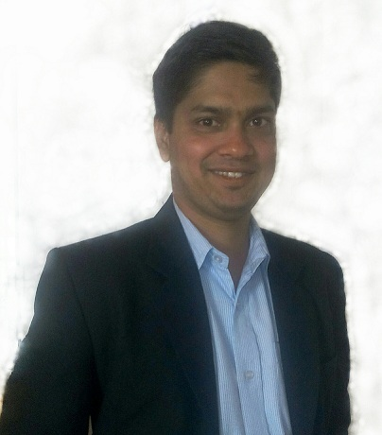

AMOL ASHOK JADHAV
Email: amoljadhav025@gmail.com
Mobile: +91-8097506577

CAREER OBJECTIVE:
A skilful experience, which demonstrates excellence in problem solving and time management and welcomes challenges. Capable of working with or without supervision and willing to assume additional responsibilities as well. Responds positively to pressure with constituency in performance and determination to achieve goals and deadlines
WORK EXPERIENCE:
1) Application Engineer
Jajoo Automation, Mumbai
Jan 2016 – till date.

2) Instrumentation Technician
Mahindra & Mahindra Tractor Division, Mumbai
Oct 2009 – Sep 2010

Roles and Responsibilities
JAJOO AUTOMATION, MUMBAI
- Working knowledge of Omron PLC Based Automation Project.
- Troubleshoot PLC based system. Programming knowledge related to Omron PLC & other products.
- Handle shop floor of Control Panel Manufacturing specially designed for Car parking system.
- Designing the control panel dimension, calculating the control components rating as per requirement, making AUTOCAD drawing of wiring, testing & troubleshooting of panel & dispatch of the control panel.
- Resolving issues of the Car Parking system Pan India programmed by our company for one of our client.
- Familiar with VFD, Stepper, Servos, Photo electric & proximity Sensors, etc.

MAHINDRA & MAHINDRA, MUMBAI
- Working on SAJ, BENZ, AVL control systems; Calibration of instruments in Engine Testing & Evaluation Department.
- Experience on engine development test bed maintenance, installation and commissioning of new equipment’s, preventive - predictive schedule Attained regular break downs of instrumentation /facility equipment’.
- Utility maintenance, electrical maintenance, Material handling equipment, ensure that all test cells are running without any issue.
- Calibration of test and measurement instruments.
- Preparing all the Documents (calibration certificate) related to Calibration of Instruments.
- Hands on Experience of temperature, pressure, Torque, Load, Distance, Speed sensors.
- Up gradation & continuous improvement in testing pane

EDUCATIONAL QUALIFICATIONS:
COURSE | INSTITUTION | UNIVERSITY  /BOARD | YEAR OF PASSING | AGGREGATE
B. E  (Electronics and Telecommunication Engineering) | Vishwabharti Academy’s College Of Engineering, Ahmednagar, Maharashtra. | Savitribai Phule  Pune University | 2015 | 64.26%  ( BE )
Diploma  (Electronics & Telecomm.) | Shah & Anchor Kuttchi Polytechnic, Chembur. | MSBTE, Maharashtra | 2009 | 70.24%
ssc | Shree Sanatan Dharam Vidyalaya, Chembur. | Mumbai | 2006 | 74.80%

Technical Qualification:
- Obtained Advanced Training in Industrial Training (ATIA) from Technocrat Automation Pvt. Limited (IAO Accredited) Chennai, with 2 months hands on practical experience in Industrial Automation Tools specializing in PLC, DCS, SCADA and VFD.

Technical Skills:
- PLC (Programmable Logic Controllers) & DCS (Distributed Control System) - Programming languages such as LD (Ladder Diagram) & FBD (Functional Block Diagram) exposure in brands as Siemens, AB (Allen Bradley), ABB (Asea Brown Boveri), Omron.

- Hands on Practical exposure in Siemens, AB, ABB, GE-Fanuc, Keyence and Omron
- SCADA (Supervisory Control & Data Acquisition) – Screen designing, PLC interface, Data collection & storage
- VFD (Variable Frequency Drive) – Commissioning and Troubleshooting
- Pneumatics & Field Instruments ( Control Valve, Sensors, Level Transmitters, Flow Transmitters, Temperature Transmitters, Pressure Switches)
- Knowledge in Panel wiring

AREA OF EXPERTISE:
- Technical Leader Ship
- Trouble Shooting and Problem Resolution
- Control Panel Manufacturing.
- Calibration of measuring instruments
- Maintain zero breakdowns.
- Panel wiring and testing.
- Designing of Automation System Architecture.

ACADEMIC Project:
Diploma Project: “AUTOMATIC RAILWAY CROSSING GATE”.
Review: The project was undertaken to design an automatics gate near railway crossings. This was based on the embedded system.

Degree Mini Project: “SMART VEHICLE SYSTEM”
Review: The project was undertaken to build a safe security system which would acts like antitheft system for vehicle. This was embedded based project in which vehicle’s handbrake would not release and even after ignition; the engine could not start unless and until a correct password was not entered to designed system.

Degree Final Project: “SOLAR OXYGEN TREE”
Review: The project is designed to increase oxygen level in surrounding environment and to use hydrogen as fuel to run the vehicle through electrolysis process. This is embedded based project in which PIC16F877A is used as the main controller.

EXTRA CURRICULAR ACTIVITIES:
- Participated in PCB designing workshop organized by “RoboMagic Technologies Pvt. Ltd”.
- Participated in Embedded Systems workshop organized by “Pantech ProEd Pvt Ltd sponsored by “Computer Society Of India”.
- Attended the three days industrial automation workshop organized by “HuNet Technologies”.

Computer Skills
Packages : Microsoft Office 2003 & 2007.
Familiar Platforms : Windows 98/2000/XP.

Personal profile:

Name : Mr. Amol Ashok Jadhav
Gender : Male
Date of Birth : 29th Oct 1990
Languages Known : English, Hindi & Marathi
Address : B/33, Dwarkha, CIBA Industrial Co-Op Housing Society, Amrutnagar, Ghatkopar(west) , Mumbai-86.

DECLARATION:
I hereby declare that the above particulars furnished by me are true to the best of my knowledge and belief.

Date:
Place: Amol Jadhav
(8097506577)

